PLUTO, ESP32 and GPSDXO VIA RASPBERRY

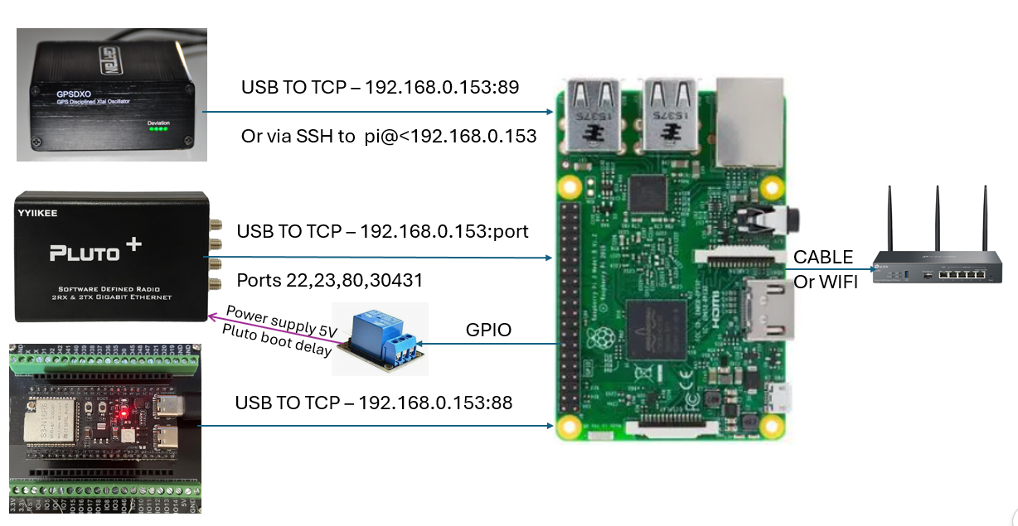

Contents
PLUTO, ESP32 and GPSDXO VIA RASPBERRY 1
Preparation of the SD Card for the Pi and basic configuration 2
Mapping a logic channel to Pluto 2
Port Mapping for Raspberry Pi3+ with OS 32 bits 2
Port Mapping for Raspberry Pi3+ with OS 64 bits (untested!!!) 3
Setup the Port forwarding 4
Next step: connect also ESP32 via USB 5
Mapping a logic channel to ESP 32 5
Expose the ESP32 via TCP 6
Next step: connect also GPSDXO via U 7
Mapping a logic channel to GPSDXO 7
If you need GPSDXO via TCP 7

Preparation of the SD Card for the Pi and basic configuration
- Prepare an SD card for Raspberry Pi with OS 32bits Light using the Raspberry Imager or other system and connect the Pi to the PC via USB
- Connect to the Pi via SSH (for example using Putty COMxx on port 22)
- Login with username and password you defined in the Raspberry Imager
- Install iptables
sudo apt install iptables
sudo apt install iptables-persistent -y
sudo apt install tcpdump -y (only for tests if something goes wrong)

- Verify the connection of the Pluto using the command “ip a”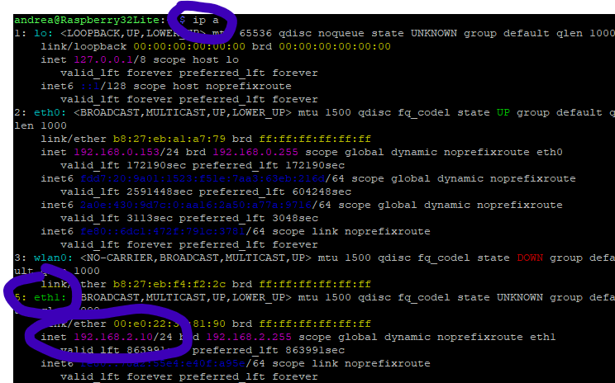

- To connect to the Pluto from the PC we have to forward what arriving on the ethernet port (for me 192.168.0.151) of the Pi to the USB port (eth1). To avoid connection conflicts, the port to connect to Pluto cannot be 22 used by the Pi but a different number (for me 23). WEW need to re-route cdata from eth0 (lan) to eth1 (USB. Unfortunately, eth0 and eth1 can swap depending on the start sequence so, before create the port forwarding, it is better to name the device Pluto with a specific name through an UDEV rule (in my case I called it pluto-usb). The rule should work with any Adalm Pluto or Plus Plus because it is recognized by vendor and product ID.

Mapping a logic channel to Pluto

It is a native ethernet channel between network (ethrnet or wifi) and the standrad IP port of Pluto (192.168.2.1) visible through a virtual interface (ie eth0, usb0…). The software (ie SDR Console od Putty on a PC) can access though standard ports (22, 23), 80, 30431 etc.).

Port Mapping for Raspberry Pi3+ with OS 32 bits
Note: nano editor can be closed with ctrl+X and the file saved following the instructions on screen.

Create a configuration file for UDEV
sudo nano /etc/udev/rules.d/99-pluto-net.rules

insert the following line
SUBSYSTEM=="net", ACTION=="add", ATTRS{idVendor}=="0456", ATTRS{idProduct}=="b673", NAME="pluto-usb"

As alternate write in the specific mac address of your Pluto (you can read it with the command “ip link show dev eth0 or eth1). This solution is much stronger but you cannot change pluto without changing the setup.
SUBSYSTEM=="net", ACTION=="add", ATTR{address}=="00:e0:22:3c:81:90", NAME="pluto-usb"

check that it works
ip a

if not restart the Pi.

Port Mapping for Raspberry Pi3+ with OS 64 bits (untested!!!)

Create a configuration file
sudo nano /etc/NetworkManager/conf.d/10-pluto-usb.conf

insert the following lines
[device-pluto-usb]
match-device=match-property:ID_VENDOR_ID==0456,match-property:ID_MODEL_ID==b673
set-name=pluto-usb

Disconnect and reconnect UDEV
sudo udevadm control --reload-rules sudo udevadm trigger --attr-match=subsystem=net

Restart the NetworkManager
sudo systemctl restart NetworkManager

check that it works
ip a

if not restart the Pi.

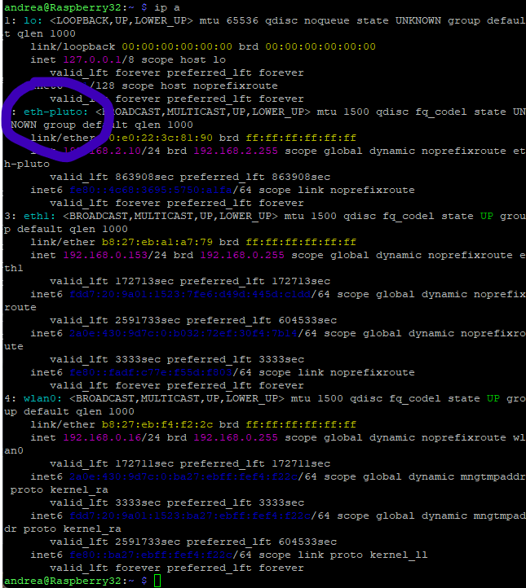
(eth-pluto now pluto-usb to avoid naming convention problems)

Setup the Port forwarding

Create a configuration file read at the startup
sudo nano /etc/sysctl.d/99-ip-forward.conf

with this line
net.ipv4.ip_forward=1

Clean the NAT table
sudo iptables -t nat -F

# Port Forwarding (Porta 23 SSH, Porta 80 Web, Porta 30431 SDR IIO)
sudo iptables -t nat -A PREROUTING -p tcp --dport 23 -j DNAT --to-destination 192.168.2.1:22

sudo iptables -t nat -A PREROUTING -p tcp --dport 80 -j DNAT --to-destination 192.168.2.1:80

sudo iptables -t nat -A PREROUTING -p tcp --dport 30431 -j DNAT --to-destination 192.168.2.1:30431

# Masquerade verso l'interfaccia fissa del Pluto
sudo iptables -t nat -A POSTROUTING -o pluto-usb -j MASQUERADE

Rewrite the routing table
sudo iptables-save | sudo tee /etc/iptables/rules.v4

That’s it, at restart you can test the connection with the Pluto
- via SSH with the same IP address of the Pi but using port 23
- via a web browser using the same ip address on the standard port 80
- with SDR Console using the standard port 30431
- any other system…

Other ports to other devices can be forwarded using the same system.

Testing active routing
sudo iptables -t nat -v -L -n --line-numbers

Next step: connect also ESP32 via USB

Mapping a logic channel to ESP 32
We need a separate channel to ESP32 that does not have an IP defined to reach to like Pluto has.

The “socat” command creates a TCP port on the Raspberry and maps it to the serial port of ESP32 (es. /dev/ttyUSB0).

Procedure:

Find the correct port of the ESP32
Unplug the ESP32 and plug it again
ls /dev/ttyUSB* /dev/ttyACM*

Find the hardware details of the connected ESP32
lsusb

Giving back something like
Bus 001 Device 004: ID 0403:6001 Future Technology Devices International, Ltd FT232 Serial (UART) IC
idVendor = 0402
idProduct = 6001

find the proper name
udevadm info -a -n /dev/ttyUSB0 | grep '{serial}'

Add it to the UDEV definition file already in place for Pluto id
sudo nano /etc/udev/rules.d/99-usb-serial.rules

add this line (symlink it’s a symbolic permanett link)
SUBSYSTEM=="tty", ATTRS{idVendor}=="0403", ATTRS{idProduct}=="6001", SYMLINK+="myESP32"
SUBSYSTEM=="tty", ATTRS{idVendor}=="0403", ATTRS{idProduct}=="7523", SYMLINK+="myGPSDXO"

Or if you have more than one ESP32
SUBSYSTEM=="tty", ATTRS{idVendor}=="0403", ATTRS{idProduct}=="6001", ATTRS{serial}=="A9008xFF", SYMLINK+="myESP32”

Ctrl+X to save

Restart UDEV or restart the Raspberry to make the mod’s active.
sudo udevadm control --reload-rules
sudo udevadm trigger

Expose the ESP32 via TCP
To make ESP32 reachable from any PC and not only the local host (127.0.0.1), socan must be modified to listen to all interfaces using the ip 0.0.0.0

socat TCP-LISTEN:88,fork,reuseaddr,bind=0.0.0.0 FILE:/dev/ttyUSB0,b115200,raw,echo=0

or

socat TCP-LISTEN:88,fork,reuseaddr,bind=0.0.0.0 FILE:/dev/myESP32,b115200,raw,echo=0

From this moment all data sent to 192.168.0.153:88 will go back and forth the ESP32.

To make it valid after shutdown and restart it must be included in a system service created with systemd:

sudo nano /etc/systemd/system/esp32-bridge.service

lines to input
[Unit]
Description=Socat Serial TCP Bridge per ESP32
After=network.target

[Service]
Type=simple
ExecStart=/usr/bin/socat TCP-LISTEN:88,fork,reuseaddr,bind=0.0.0.0 FILE:/dev/myESP32,b115200,raw,echo=0
Restart=always
RestartSec=5

[Install]
WantedBy=multi-user.target

Not it has to be read and started and authorized for automatic execution
Reload configuration of systemd
sudo systemctl daemon-reload

Authorize the automatic execution at startup
sudo systemctl enable esp32-bridge.service

Start the service immediatly
sudo systemctl start esp32-bridge.service

Test restart of the Raspberry and pray.

Next step: connect also GPSDXO via U

Mapping a logic channel to GPSDXO
Explanation same as per ESP32!!! Since the required connection is only SSH (no TCP) there is a shorter way that does not require other that define the UDEV device

Procedure (just name change):

Find the correct port of the GPSDXO
Unplug the GPSDXO and plug it again
ls /dev/ttyUSB* /dev/ttyACM*

Find the hardware details of the connected GPSDXO
lsusb

Giving back something like
Bus 001 Device 004: ID 0403:6001 Future Technology Devices International, Ltd FT232 Serial (UART) IC
idVendor = 0402
idProduct = 6001

find the proper name
udevadm info -a -n /dev/ttyUSB0 | grep '{serial}'

Add it to the UDEV definition file already in place for Pluto id
sudo nano /etc/udev/rules.d/99-usb-serial.rules

add this line (symlink it’s a symbolic permanett link)
SUBSYSTEM=="tty", ATTRS{idVendor}=="0403", ATTRS{idProduct}=="7523", SYMLINK+="myGPSDXO"

Or if you have more than one GPSDXO
SUBSYSTEM=="tty", ATTRS{idVendor}=="0403", ATTRS{idProduct}=="6001", ATTRS{serial}=="B9008xFF", SYMLINK+="myGPSDXO”

Ctrl+X to save

Restart UDEV or restart the Raspberry to make the mod’s active.
sudo udevadm control --reload-rules
sudo udevadm trigger

At this point to connect the GPSDXO from the PC you can just type in CMD
ssh -t pi@<IP_DEL_RASPBERRY> "minicom -D /dev/myGPSDXO -b 115200"

If you need GPSDXO via TCP
To make GPSDXO reachable from any PC and not only the local host (127.0.0.1), must be modified to listen to all interfaces using the ip 0.0.0.0

socat TCP-LISTEN:89,fork,reuseaddr,bind=0.0.0.0 FILE:/dev/myGPSDXO,b115200,raw,echo=0

From this moment all data sent to 192.168.0.153:88 will go back and forth the GPSDXO.

To make it valid after shutdown and restart it must be included in a system service created with systemd:

sudo nano /etc/systemd/system/gpsdxo-bridge.service

lines to input
[Unit]
Description=Socat Serial TCP Bridge per GPSDXO
After=network.target

[Service]
Type=simple
ExecStart=/usr/bin/socat TCP-LISTEN:89,fork,reuseaddr,bind=0.0.0.0 FILE:/dev/myGPSDXO,b115200,raw,echo=0
Restart=always
RestartSec=5

[Install]
WantedBy=multi-user.target

Not it has to be read and started and authorized for automatic execution
Reload configuration of systemd
sudo systemctl daemon-reload

Authorize the automatic execution at startup
sudo systemctl enable gpsdxo-bridge.service

Start the service immediatly
sudo systemctl start gpsdxo-bridge.service

Test restart of the Raspberry and pray.

⚠️ Warning 1⚡

Be sure that the power supplied to Pluto, ESP and GPSDXO will not go all though the Raspberry because it can handle max 1.25A in total (summing up all USB connected consumptions). Pluto cannot be powed though Raspberry!!! It works receiving but get stuck if you try to transmit.

You might want to add a USB Hub to connect your devices.

⚠️ Warning 2

Pluto requires that the GPSDXO signal (40 MHz) is available when turned on instead it gets stuck. Normally GPSDXO generates the RF signal when starts but it may take too long for Pluto. To avoid troubles, it is better to delay the Pluto startup after that the Pi and GPSDXO are on.

If you put a timer, remember to cut the red wire of the USB cable from the Pi to the Pluto to avoid Pluto getting power directly from the Pi.

That is not mandatory, but it solves unpredictable problems when you turn the system on.

SOLUTION

- Cut the red wire of the USB connection to the Pluto DATA and use a 5V photocoupled relays module connected to the Pi’s GPIO:
VCC Pin 4 or 2
GND Pin 6
IN Signal Pin 11 (GPIO 17)

Connect COM (common) to 5V supply and NO + GND to Pluto POWER USB input.

- Create a Python timer to control the delay the relays when the Pi starts.

nano /home/pi/pluto_start.py

add lines

import time
from gpiozero import OutputDevice

# Wait 1 minute from beginning of the script launched in the startup sequence

time.sleep(60)

# GPIO 17 (Pin 11) configuration (active_high=false in case of inverted logic)

rele = OutputDevice(17, active_high=True, initial_value=False)

# Turn on the realay (hence Pluto)
rele.on()

- Create the system service

sudo nano /etc/systemd/system/pluto-timer.service

add lines

[Unit]
Description=Delayed Pluto boot
After=multi-user.target

[Service]
Type=simple
ExecStart=/usr/bin/python3 /home/pi/pluto_start.py
Restart=on-failure

[Install]
WantedBy=multi-user.target

- Service habilitation to be executed at each boot
sudo systemctl daemon-reload
sudo systemctl enable pluto-timer.service

GL and 73 by I2TPY

